**Exercise 1: Configuring a Basic Spring Application**

**Scenario:**

Your company is developing a web application for managing a library. You need to use the Spring Framework to handle the backend operations.

**Steps:**

1. **Set Up a Spring Project:**
   * Create a Maven project named **LibraryManagement**.
   * Add Spring Core dependencies in the **pom.xml** file.
2. **Configure the Application Context:**
   * Create an XML configuration file named **applicationContext.xml** in the **src/main/resources** directory.
   * Define beans for **BookService** and **BookRepository** in the XML file.
3. **Define Service and Repository Classes:**
   * Create a package **com.library.service** and add a class **BookService**.
   * Create a package **com.library.repository** and add a class **BookRepository**.
4. **Run the Application:**
   * Create a main class to load the Spring context and test the configuration.

**pom.xml**

<project xmlns="http://maven.apache.org/POM/4.0.0"

xmlns:xsi="http://www.w3.org/2001/XMLSchema-instance"

xsi:schemaLocation="http://maven.apache.org/POM/4.0.0

http://maven.apache.org/xsd/maven-4.0.0.xsd">

<modelVersion>4.0.0</modelVersion>

<groupId>com.library</groupId>

<artifactId>LibraryManagement</artifactId>

<version>1.0</version>

<dependencies>

<!-- Spring Context Dependency -->

<dependency>

<groupId>org.springframework</groupId>

<artifactId>spring-context</artifactId>

<version>5.3.32</version>

</dependency>

</dependencies>

</project>

**applicationContext.xml**

<?xml version="1.0" encoding="UTF-8"?>

<beans xmlns="http://www.springframework.org/schema/beans"

xmlns:xsi="http://www.w3.org/2001/XMLSchema-instance"

xsi:schemaLocation="http://www.springframework.org/schema/beans

http://www.springframework.org/schema/beans/spring-beans.xsd">

<bean id="bookRepo" class="com.library.BookRepository"/>

<bean id="bookService" class="com.library.BookService">

<property name="bookRepository" ref="bookRepo"/>

</bean>

</beans>

**BookService.java**

package com.library;

public class BookService {

private BookRepository bookRepository;

public void setBookRepository(BookRepository bookRepository) {

this.bookRepository = bookRepository;

}

public void display() {

System.out.println("BookService: Displaying...");

bookRepository.show();

}

}

**BookRepository.java**

package com.library;

public class BookRepository {

public void show() {

System.out.println("BookRepository: Showing book details.");

}

}

**Main.java**

package com.library;

import org.springframework.context.ApplicationContext;

import org.springframework.context.support.ClassPathXmlApplicationContext;

public class Main {

public static void main(String[] args) {

ApplicationContext context = new ClassPathXmlApplicationContext("applicationContext.xml");

BookService service = (BookService) context.getBean("bookService");

service.display();

}

}

package com.library;

import org.springframework.context.ApplicationContext;

import org.springframework.context.support.ClassPathXmlApplicationContext;

public class Main {

public static void main(String[] args) {

ApplicationContext context = new ClassPathXmlApplicationContext("applicationContext.xml");

BookService service = (BookService) context.getBean("bookService");

service.display();

}

}

**Output:**

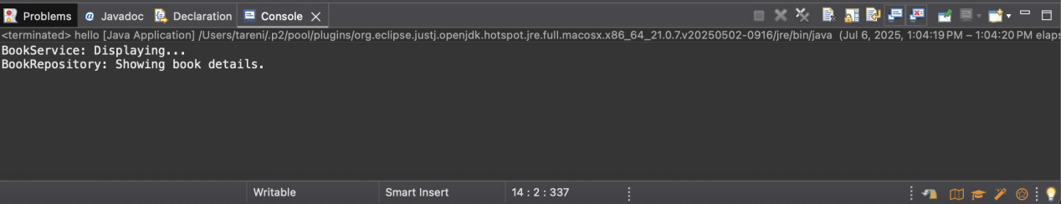

BookService: Displaying...

BookRepository: Showing book details.